Workshop
Planning
Notes

Here is the rough program

Intro Andrew

- Self Care

- The route of healthy relationship is to care for yourself – Love other as you love yourself into Rhea
- Go through the diagram below starting with Rest and talk it interns to explain and go deeper into each one. Each part will click through as we go to build up the picture

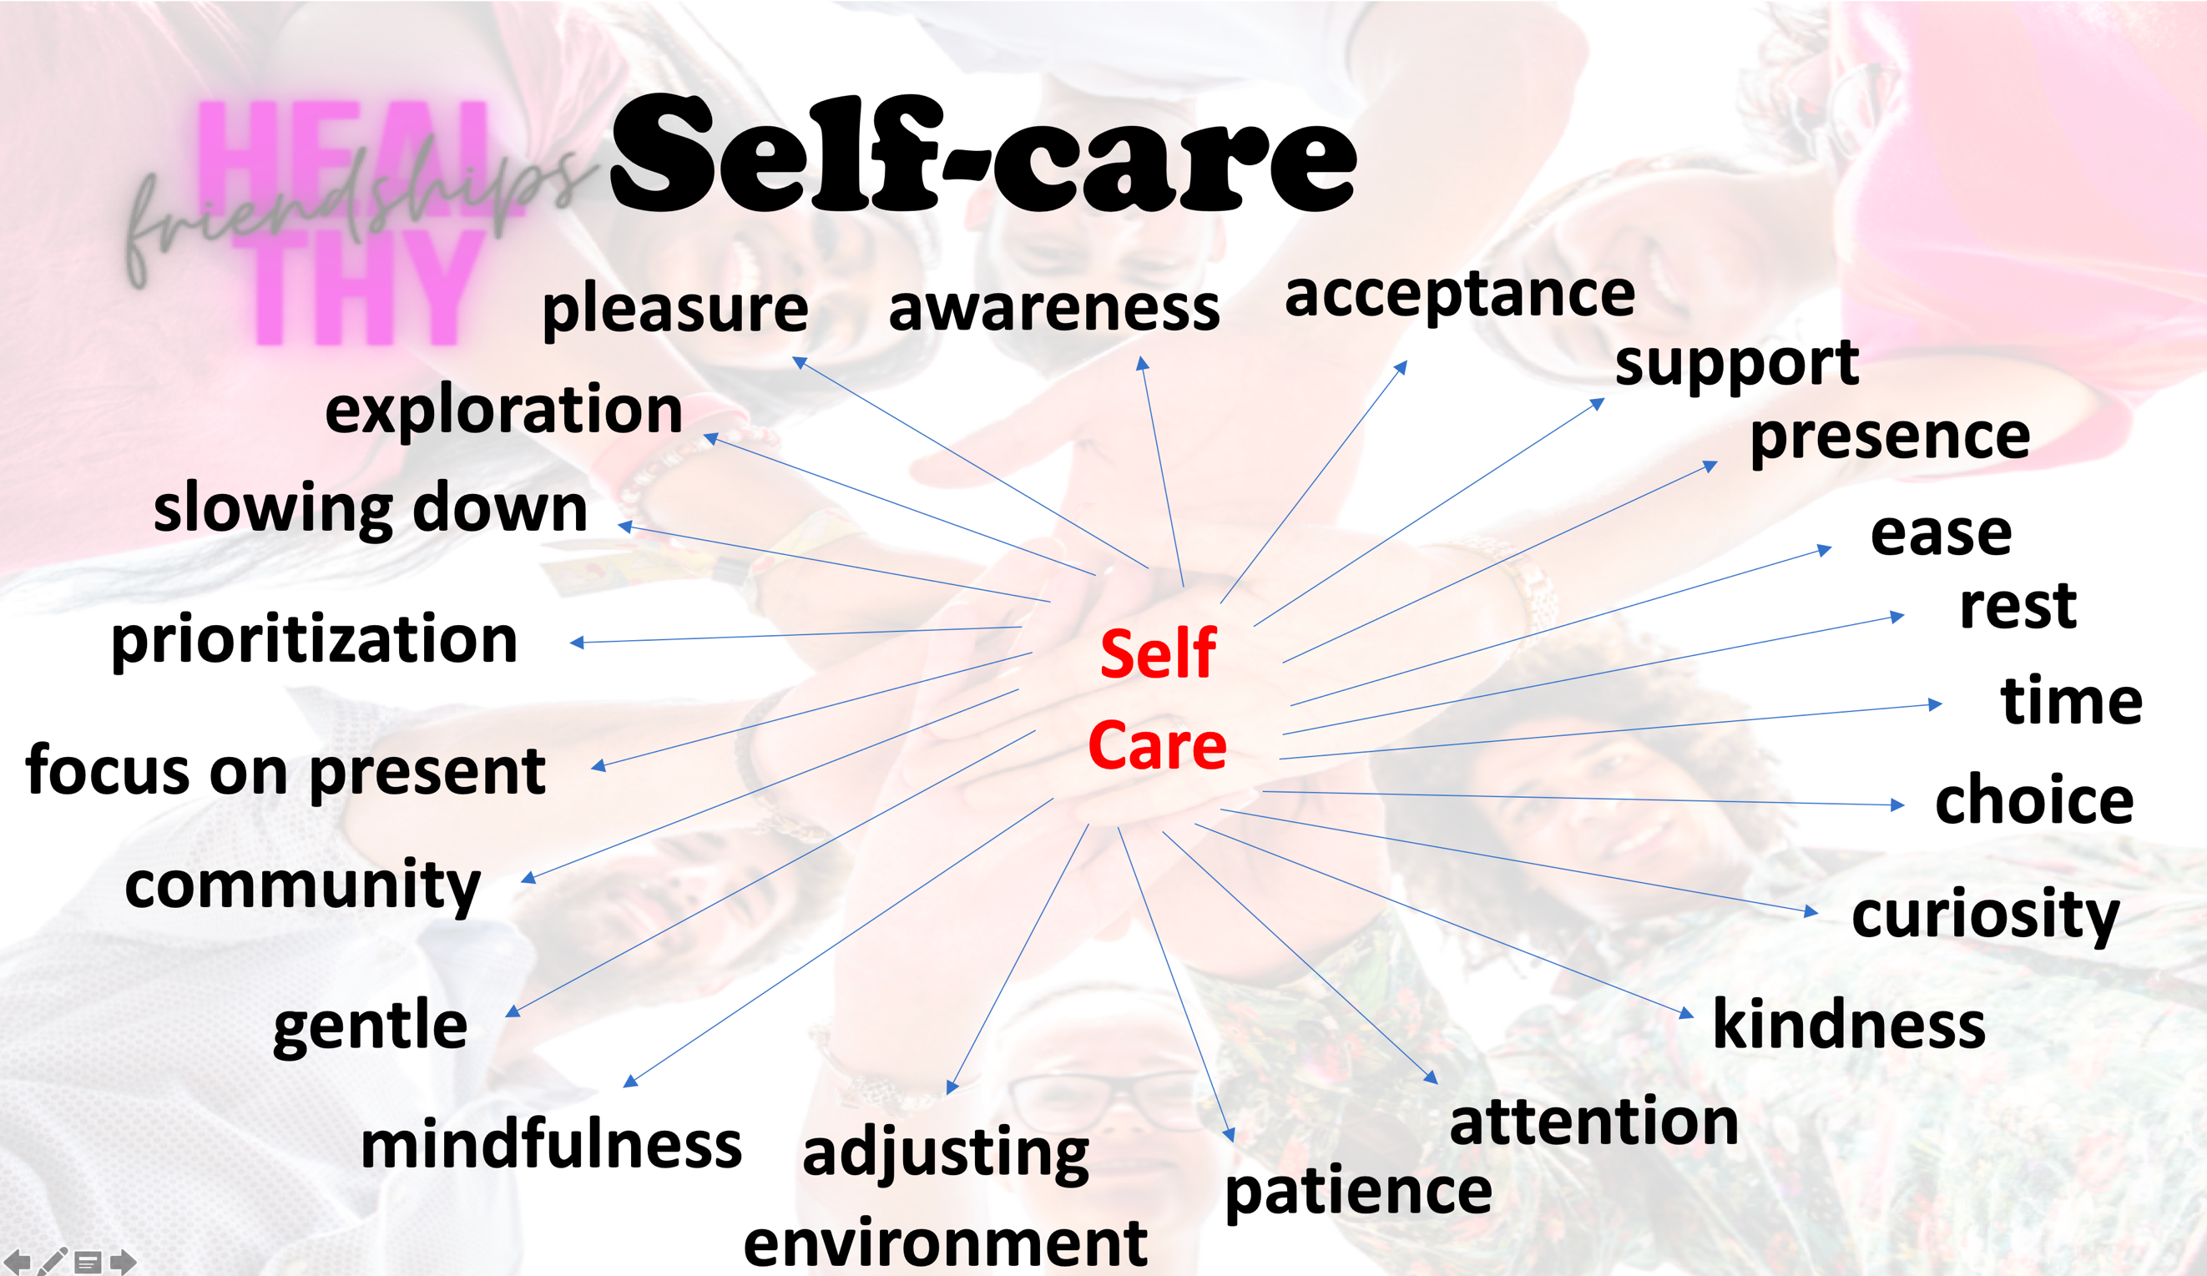

- Friendship Types

- First slide on listing friends – Andrew to intro
- Rhea to go through Confidents

Basic explanation – please expand – slide will click through each one

Confidants are those people in your life that love you unconditionally and who are 100% into you as a person. They don’t care whether you are in pain or happy, right or wrong…they don’t care if you are in trouble, because they will get into trouble with you. They will come visit you when you are down and they will drag you out of a place of hell. You can open up and share anything with these people because they believe in you. Confidants are people who feed you while you are feeding the minds of other people. They are those who make you reach out for more when you are already living a good life. These confidants come around once in a while, and they are few. They are intertwined into your life. They will get in your face, they will get in your business, they will tell you when your wrong…because they are confidants…it is because they love you. Without these people, you will never be who you can be.

- Andrew to go through Constituents

Constituents are those people who are not into you like the confidants, but they are into what you are for. As long as you are for what they are for, they will walk with you and labor with you, “but never think that they are for you, they are for what you are for.” If they meet someone else who will further their agenda, they will leave you and they will go for what that other person is for. Constituents believe in what you believe, but never be mistaken by what the constituent is really about. The constituents are important because they do believe in your cause and will support you through it.

- Rhea to go through Comrades

Comrades are not for you, they are not for what you are for, but they are against what you are against. They will team up with you to help fight a greater enemy. They will only be with you until the victory is accomplished. “These people are like scaffolding, they come into your life to fulfill a purpose, and when the purpose is complete, the scaffolding is removed. But don’t be upset when the scaffolding is removed…because the building remains.” I love the imagery of this because it is so true. We have people in our lives who are incredibly important to us because they hold us up when we need help. The scaffolding is an important job.

- Andrew to go through Conclusions

Expect the constituents and the comrades to leave you and desert you after a while. Because of this, be careful who you tell your dream to. If you tell your dream to your constituents, they will leave you and try to accomplish the dream by themselves. If you tell your dream to your comrades, they will desert you because they were never there for you in the first place. If people are really for you, they will weep when you weep, and they will rejoice when you rejoice. “I can tell you how to identify people who are really for you. When you walk in a room and you tell someone good news, stop being happy for a minute and watch their reaction, if they are not happy for you, shut your mouth and walk right back out of the door. When they are really connected with you, they will be happy for you when you share your dream.”
You need someone who will be really happy for you. You have to find someone who is behind you 100% and is vouching for you as if it was them. His speech resonated with me significantly because I have had trouble letting people go in the past. But now I realize, people were meant to come and go. Celebrate their purpose, and be happy. I also will carry with me the character of the three different types of people. I never truly thought of it this way, but now that I have heard it, it really makes sense. Remember, your confidants are those who will guide your hand and make you reach for more. They will be the people in your life that truly believe in you, and your dreams. Hold onto your confidants…they are blessings.
- Rhea to go through application slide

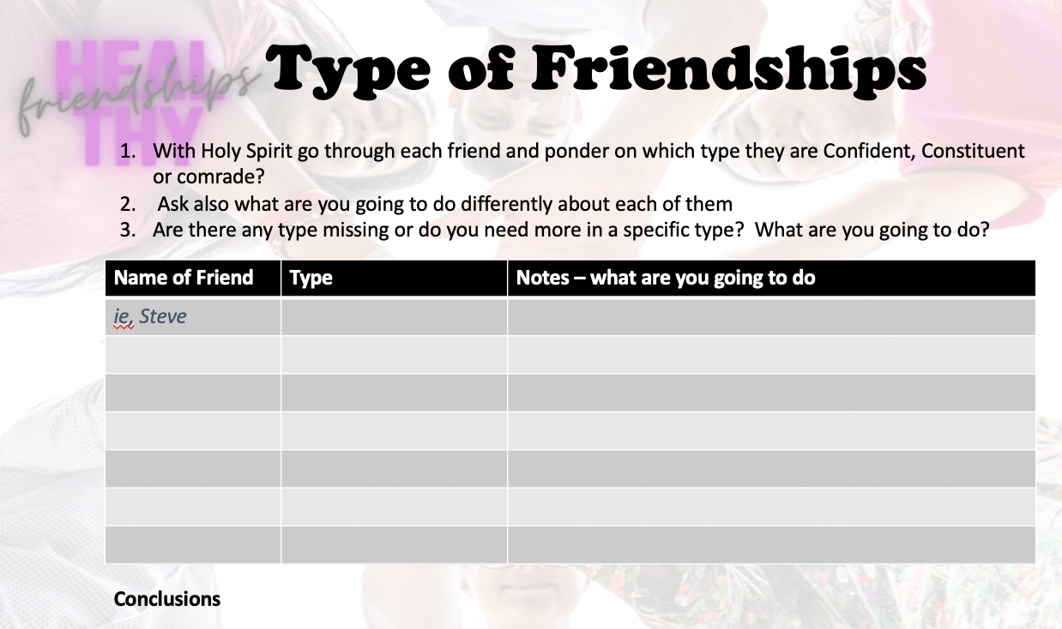

- Boundaries

- Rhea to intro

When we set healthy boundaries, we practice self-respect, self-care, and authenticity.

We improve our relationships with those around us by defining our ground rules and setting expectations with a sense of fairness and clarity.
Unfortunately, boundaries are often set only after we’ve been pushed too far. We become angry and resentful. The relationship has likely already deteriorated beyond repair. The earlier we make our boundaries known, the less likely they are to be violated. Learning to set a firm boundary early on can often save the life of a relationship.

This is what healthy boundaries sound like:

- “I am not okay with you yelling at me. I will discuss this when we can speak to one another calmly and respectfully.”
- “I can’t work overtime this weekend. Since I wasn’t on the schedule, I already made plans.”
- “I can give you a ride home, but I absolutely need to leave by seven. If you’re any later than that I’m going to have to leave without you.”
- “Your friend has a drug problem, and I’m not comfortable being around him. Please don’t invite him over to our house again.”
- “I’ve been doing much more than my fair share of the chores. From now on, I’m only washing my own dishes. I’ll expect you to wash your own.”

- Andrew on identify your needs

Learning to set boundaries like these can be difficult. Here’s how to do it in four simple steps:

1. Identify your needs.

What happened that made you realize the need for a healthy boundary? How did you feel? Do you have a good reason for setting this boundary, or are you looking for a way to punish someone in the heat of the moment? How, specifically, do you need things to change going forward? How will this impact your life? Your relationship? Your partner? Is setting this boundary fair and reasonable to all involved? Take time to reflect on your emotional needs and identify the desired impact of your boundary. You should have a clear goal in mind – for example, feeling safer, being treated fairly, or relating to one another in a more positive way.

- Rhea on define boundary

2. Define your boundary.
Be as clear and specific as possible. A boundary needs to be concrete and easily understood in order to be enforced effectively. For example, rather than asking your husband to help out more with the housework, you might request that he take on responsibility for sweeping the floors or doing the dishes. Attach a consequence to the boundary being broken, so your loved one knows what to expect. Your loved ones want to respect your boundaries. Not understanding how to do so can leave them feeling confused, frustrated, and incompetent. Set your boundaries on the firmer side – it is much easier to ease up on a strict boundary than to tighten a loose one.

- Andrew on identify your needs

3. Make your boundary known.

Be firm, but remain as calm and kind as possible. Treat the other person with respect. Remember, you are asking for their cooperation. The more courtesy and respect you show, the more likely you are to receive it. However, there is a difference between being polite and being a pushover. Even as you communicate it with respect, your boundary should remain firm. Don’t apologize for setting it. Don’t explain excessively. You don’t need to justify your behavior. Communicate your new boundary quickly and clearly to avoid confusion. Avoid placing personal blame, and reinforce the fact that you value this relationship.

- Rhea on define boundary

4. Enforce your boundary.
Some people will try to test your new boundaries by violating them early on. Don’t allow this to slide. If you do, you are breaking this boundary and weakening every one you might try to set in the future. Enforce your boundary by carrying out the consequence you originally set – no more and no less. If you promised to remove a certain privilege, do so immediately. If you said you would move out, it is now your responsibility to follow through. This is why it is important to set realistic consequences before the boundary is violated. If you have nothing to enforce, then your boundary has no legs to stand on and is likely to fall apart.

- Andrew conclusions and ask the question

“When we fail to set boundaries and hold people accountable, we feel used and mistreated. This is why we sometimes attack who they are, which is far more hurtful than addressing a behavior or a choice,” wrote Brené Brown. Setting boundaries may seem harsh, but doing so is necessary in maintaining a healthy relationship.
What boundaries do you need to set in your life?

